Computing Essential Knowledge and skills Summer KS1 2022-2023
N.C Objectives: Key Stage 1 | Essential 1 | Essential 2 | Essential 3
Understand what algorithms are; how they are implemented as programs on digital devices; and that programs execute by following precise and unambiguous instructions. (Computer Science)  Create and debug simple programs.  (Computer Science)  Use logical reasoning to predict the behaviour of simple programs.  (Computer Science) | Knowledge  Understand that an algorithm is a set of instructions used to solve a problem or achieve an objective. Know that an algorithm written for a computer is called a program.  Write their own simple algorithm.  Children know that an unexpected outcome is due to the code they have created and can make logical attempts to fix the code. | Knowledge  Explain that an algorithm is a set of instructions to complete a task.  Show an awareness of the need to be precise with their algorithms so that they can be successfully converted into code. | Knowledge  Identify the parts of a program that respond to specific events and initiate specific actions. (For example, they can write a cause and effect sentence of what will happen in a program.)
 | Skills  Work out what is wrong with a simple algorithm when the steps are out of order.  Purple Mash Units 1.7 / 1.5  BEEBOTS | Skills  Create a simple program that achieves a specific purpose.  Identify and correct some errors using a growing awareness of the need for logical, programmable steps.  Purple Mash Units 2.1 / BEEBOTS | Skills  Create and Debug a range of different programs.
 | Target Tracker objectives:  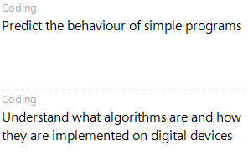 | Target Tracker objectives:  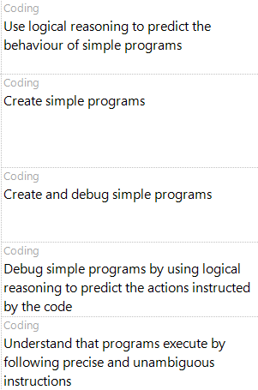
Computing Essential Knowledge Summer LKS2 2022-2023
N.C Objectives: Key Stage 2 | Essential 1 | Essential 2 | Essential 3
Key Stage 2  N.C Objectives:  Design, write and debug programs that accomplish specific goals, including controlling or simulating physical systems; solve problems by decomposing them into smaller parts. (Computer Science)  Use sequence, selection and repetition in programs; work with variables and various forms of input and output. (Computer Science)  Use logical reasoning to explain how some simple algorithms work and to detect and correct errors in algorithms and programs. (Computer Science) | Knowledge  Turn a simple real-life situation into an algorithm for a program by deconstructing it into manageable parts.  Design and code a program that follows a simple sequence.  Understand how variables can be used. | Knowledge  Turn a real-life situation into an algorithm, showing coding structures for selection and repetition.  Design and code a program logically using repetition effects.  Use and manipulate variables. | Knowledge  Design programs showing that they are thinking of the structure in logical, achievable steps and absorbing some new knowledge of coding structures.
 | Skills  Identify an error within their program that prevents it following the desired algorithm and then fix it.  Purple Mash Unit 3.1 / KODU | Skills  Debug their own programs using logical reasoning.  Decompose programs into smaller parts.  Purple Mash Unit 4.1 /KODU | Skills  Predict the outcome of programs accurately.
 | Target Tracker objectives:  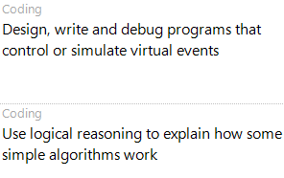 | Target Tracker  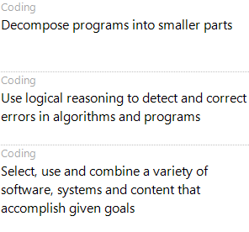

Computing Essential Knowledge Summer UKS2 2022-2023
N.C Objectives: Key Stage 2 | Essential 1 | Essential 2 | Essential 3
Key Stage 2  N.C Objectives:  Design, write and debug programs that accomplish specific goals, including controlling or simulating physical systems; solve problems by decomposing them into smaller parts. (Computer Science)  Use sequence, selection and repetition in programs; work with variables and various forms of input and output. (Computer Science)  Use logical reasoning to explain how some simple algorithms work and to detect and correct errors in algorithms and programs. (Computer Science) | Knowledge  Attempt to turn more complex real-life situations into algorithms for a program by deconstructing it into manageable parts. | Knowledge  Turn a more complex programming task into an algorithm by identifying the important aspects of the task (abstraction) and then decomposing them in a logical way. | Knowledge  Interpret a program in parts and make logical attempts to put the separate parts of a complex algorithm together to explain the program as a whole.
 | Skills  Test and debug their programs as they go and can use logical methods to identify the approximate cause of any bug.  Translate algorithms that include sequence, selection and repetition into code with increasing ease.  Combine sequence, selection and repetition with other coding structures to achieve their algorithm design.  Purple Mash Unit 5.1 / SCRATCH | Skills  Test and debug their program as they go and use logical methods to identify the cause of bugs, demonstrating a systematic approach to try to identify a particular line of code causing a problem.  Translate algorithms that include sequence, selection and repetition into code and their own designs show that they are thinking of how to accomplish the set task in code utilising such structures, including nesting structures within each other. Purple Mash Unit 6.1 / SCRATCH | Skills  Use their knowledge of coding structures and apply skills from previous programs.
 | Target Tracker objectives:  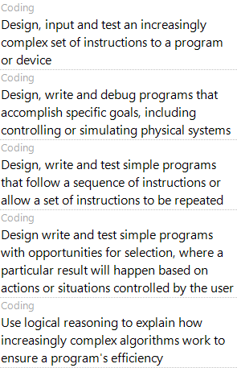 | Target Tracker  