Maths Curriculum Map 2021-2022
Based on Tara Loughran’s Build a Sequence.

 |  | Autumn |  | Spring |  | Summer
EYFS |  | Number a week |  | Number a week |  | Number a week
 |  | Tailored to the children’s needs and |  | Tailored to the children’s needs and |  | Tailored to the children’s needs and
 |  | understanding |  | understanding |  | understanding
Year |  | Number: Place value (within 10) |  | Number: Place Value |  | Fractions
1 |  | Counting within 5 |  | counting in multiples of 2s, 5s, 10s |  | Halves and Quarters
 |  | Counting within 10 |  | Multiplication and Division |  | Multiplication and Division
 |  | Subitising |  | Halves and doubles |  | Solve 1 step problems
 |  | Count all |  | Halves and doubles |  | Solve 1 step problems
 |  | Count all |  | Addition and Subtraction |  | Arrays
 |  | Leading to ordering +1/-1 |  | Addition and Subtraction |  | Arrays
 |  | Leading to ordering +1/-1 |  | T and O not crossing |  | Addition and Subtraction
 |  | Number: Addition and Subtraction (within 10) |  | (using prior knowledge of bonds) |  | Crossing tens
 |  | Number: Addition and Subtraction (within 10) |  | Measurement |  | Addition and subtraction facts within 20
 |  | Bonds to 4, 5, 6, 7, 8, 9, 10 |  | Measurement |  | Addition and subtraction facts within 20
 |  | Language of = to, more, less than, fewer |  | and comparison across all measures |  | 1 step number problems
 |  | Counting on and back |  |  |  | Place Value
 |  | Number: Place Value |  |  |  | Partitioning 2-digit numbers into T and O
 |  | Number: Place Value |  |  |  | Geometry and Time
 |  | (within 20) |  |  |  | O’clock
 |  | Counting up to 20 |  |  |  | Half past
 |  | Measure
 |  | Capacity
 |  | Geometry
 |  | Shape properties
 |  | 2d and 3d

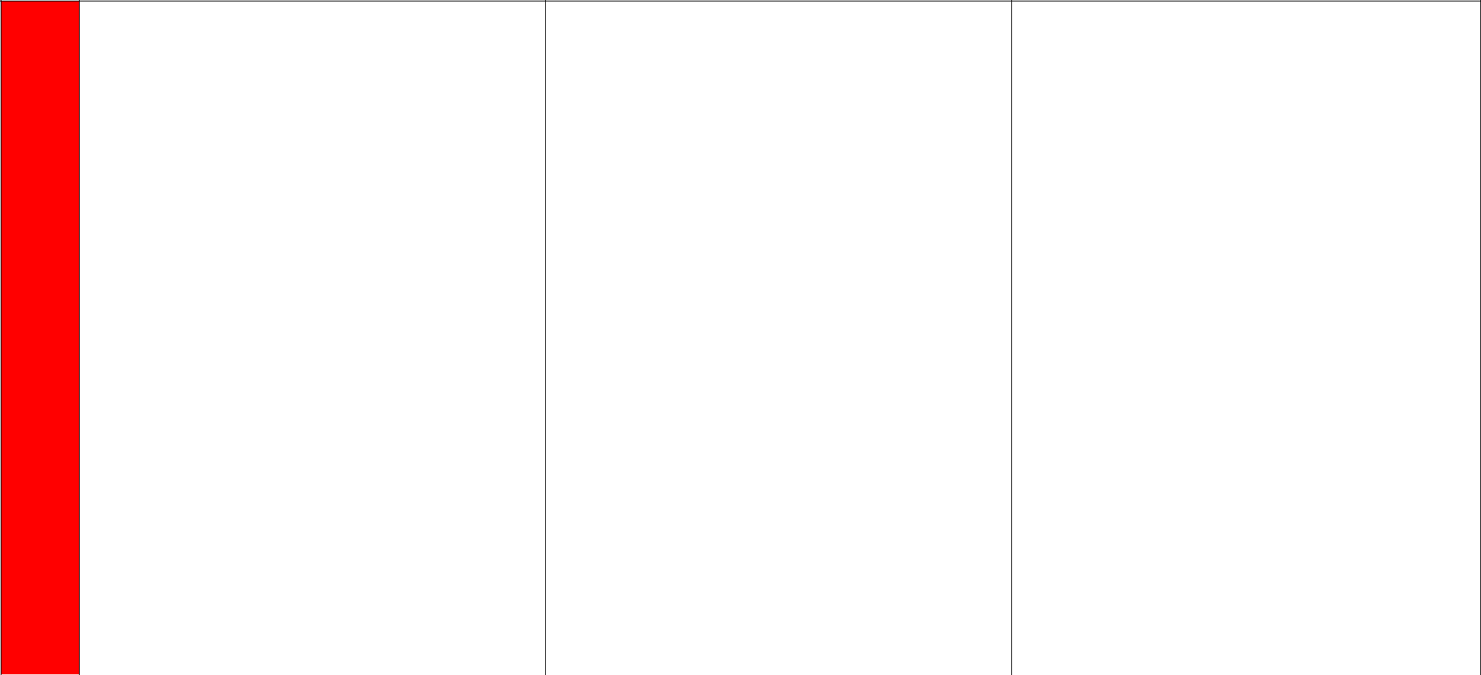
Year
2

Number: Place Value
PV of digits in TO
Partitioning numbers into T and O including
other combinations
Estimate and recognise numbers on a number
line

Compare and Order numbers up to 100

using > < and =

Addition and Subtraction Bonds of multiples of 10 2 digit both numbers are tens 2 digit + tens e.g. 43 + 30 (not crossing 100) Reinforce putting the biggest number first

Multiplication and Division (Carry on into
Spring)
Arrays
Commutativity

Problem Solving
Division problems

Recall of the facts 2s 3s 5s 10s
Halves and Doubles
Place value – counting in 2s 3s 5s from 0

Counting in tens from any number

Addition and Subtraction Adding 3 1 digit numbers Subtracting 3 1 digit numbers TO +/- TO not crossing boundary TO + O crossing boundaries TO – O crossing boundaries

Geometry
Properties of shape 2d and 3d

Describing and comparing

Fractions
Recognise and find 1/3 ¼ 2/4 ¾ of length, shape

and quantity
Equivalence of ½ and 2/4

Time
Quarter to
Quarter past

Multiplication and Division
Arrays
Commutativity
Problem Solving

Division problems

Measure

Length and Capacity

Position and Direction
Patterns and sequences

Addition and Subtraction
TO + TO to 100
TO – TO to 100

Statistics

Simple pictograms and tables

Totalling data

Addition and Subtraction
TO+TO

TO–TO




Year
3

Number: Place Value
Recognise pv in each digit in HTO
Compare and order numbers up to 1,000
Identify represent and estimate umbers up to
1,000
Number: Addition and Subtraction

Add 3 single digits

(up to) 3 digit + ones
(up to) 3 digit + tens
(up to) 3 digit + hundreds
(up to) 3 digit - ones
(up to) 3 digit - tens
(up to) 3 digit - hundreds
TO+ TO crossing hundreds
TO – TO crossing tens
(Column method not required at this point in the
year)
Measure
Length and Capacity

Fractions
Find ½ ¼ 1/3 of a given amount

Number: Multiplication and Division
Count in 4s 8s 50s from 0
3x 4x 8x facts
Division facts
Statistics

Pictograms (where the whole picture is worth
more than one)
Position and Direction
Patterns and sequences

Fractions
Find fractions of shapes, amounts
Recognise and use fractions as numbers
Compare and order fractions

Not tenths

Geometry

Property of 2d and 3d shape
Turns
Right angles horizontal, vertical, parallel and
perpendicular lines

Time
Analogue clocks
Roman Numerals

Addition and Subtraction
TO + TO crossing hundreds
TO – TO crossing tens

Measurement
Length and Perimeter

Multiplication and Division

Division with remainders

Fractions
Add and subtract fractions within 1 whole

Decimals

0.1 = 1/10

Addition and Subtraction

Column method HTO + HTO
Column method HTO – HTO

Measure

Compare mass

Multiplication and Division
TOXO

TO÷O

Measure
Capacity

Statistics
Interpret and present data using bar charts,
pictograms, tables

Year
4

Number: Place Value

Count in 7s 9s 25s 1,000s
Find 1,000 more / less
Order and compare numbers beyond 1,000

Recognise pv of each digit in a 4 digit number

Rounding to nearest 10, 100, 1,000

Addition and Subtraction

Addition of 3 digit multiples of 10

Mental addition and subtraction using 100s and
1000s

Add and subtract 3 digit using mental strategies
Columnar methods
HTO + HTO

HTO - HTO

Statistics
Bar charts

Multiplication and Division
Facts for 6s, 7s, 9s, 11s, 12s

X by 0 and 1

- by 1 TO x O
Division with remainders

TO÷O
Statistics

Pictograms

Measurement
Length and Perimeter

Area

Geometry / Measure
Properties of 2d and 3d shape

Right angles
Horizontal and vertical parallel and perpendicular
lines

Fractions
Find fractions of shapes and amounts.
Recognise and use fractions as numbers
Compare and order fractions

Not tenths
Equivalent fractions
Fractions of quantities

Add and subtract fractions within 1 whole

Addition and subtraction of fractions with the same
denominator across 1 whole

Decimals
Decimal equivalents
0.1 = 1/10
Multiplying and Dividing by 10 and 100
Decimal equivalents
Rounding and comparing decimals Recognise tenths and hundredths

Addition and Subtraction

Add and subtract numbers to one decimal place

Time

Roman Numerals
Read, write and convert 12 and 24

Convert hours to minutes, minutes to seconds, years

to months, weeks to days

Statistics

Time Graphs

Multiplication and Division

Factor pairs

Written methods for TO X O HTO X O
TO ÷ O inc remainders

Geometry / Measure Properties of 2d and 3d shape Perimeter

Measurement

Length

Decimals

Fraction and decimal equivalents

Addition and subtraction of up to 4 digits with

decimals

Geometry Position and Direction
Co-ordinates

Positions and translations

Place Value Negative numbers

Measurement Capacity

Statistics

Bar charts
Time graphs
Time tables

Year
5

Number: Place value
All strands of NC

Negative Numbers

Multiplication and Division
Multiplying whole numbers and decimals by 10,

100, 1,000

Converting units of measure
X and ÷ mentally drawing on known facts

Perimeter and Length

Capacity
Year 4 objectives

Multiplication and Division
Factor Pairs
Written methods for TO X O
HTOXO

TO ÷ O including remainders
Properties of number – sq, cubed, factors, prime

Addition and Subtraction
Mental vs Written

Decimals
+/- up to 4 digit with decimals
Partition and order numbers to 2dp
Round to 1dp
Reading and expressing at decimals
Order and compare to 3dp
Fraction and decimal equivalence

Fractions
Recognising mixed numbers and improper
fractions
Order with denominators which are all multiples

of the same number
Add and subtract where denominators and

multiples of the same number

Multiplying proper fraction by whole numbers

Measurement

Reading timetables

Multiplication and Division 4 digit x 1 digit 2 digit x 2 digit 3 digit x 2 digit 3 digit ÷ 1 digit 4 digit ÷ 1 digit

Measurement
Area

Volume

Percentages.

Geometry
Properties of 2d shape
Angles
Area and Perimeter
Coordinates, positions and translations

Addition and Subtraction
Decimal numbers

Statistics

All objectives

Measure
Involving all operations


Year
6

Number: Place Value
Revise all NC objectives
Multiplication and Division
Factors, multiples, prime numbers

X powers 100
4 digit x 2 digit

4 digit ÷ 2 digit

BODMAS (if secure)
Measure
Area and Perimeter
Converting units of measure

Addition and Subtraction
Word problems
All methods

Revise all NC objectives

Fractions
Simplifying fractions
Comparing fractions
Add and subtract with different denominators

Multiplying proper fractions Dividing proper fractions by a whole number

Decimals, percentages
Equivalents
Parts of whole shape, quantity compare and
order

Ratio and Proportion
Problem solving involving:
Missing values (x and ÷)
Calculation of percentages
Shapes and scale factors

Fractions and multiples

Statistics
Pie Charts

Line graphs
Time graphs
Mean, median, mode, range

Geometry
Position and direction
Position in all 4 quadrants

Translation
Reflections

Geometry:
Properties of 2d and 3d shape

Algebra
Simple formulae
Generate and describe linear sequences

Multi-step problems
All contexts

Algebra
Generate and describe linear sequences
Express missing number problems algebraically Find pairs of numbers that satisfy an equation with 2 unknowns

Properties of Number
Sequences – triangular numbers
Fibonacci

Maths through art

