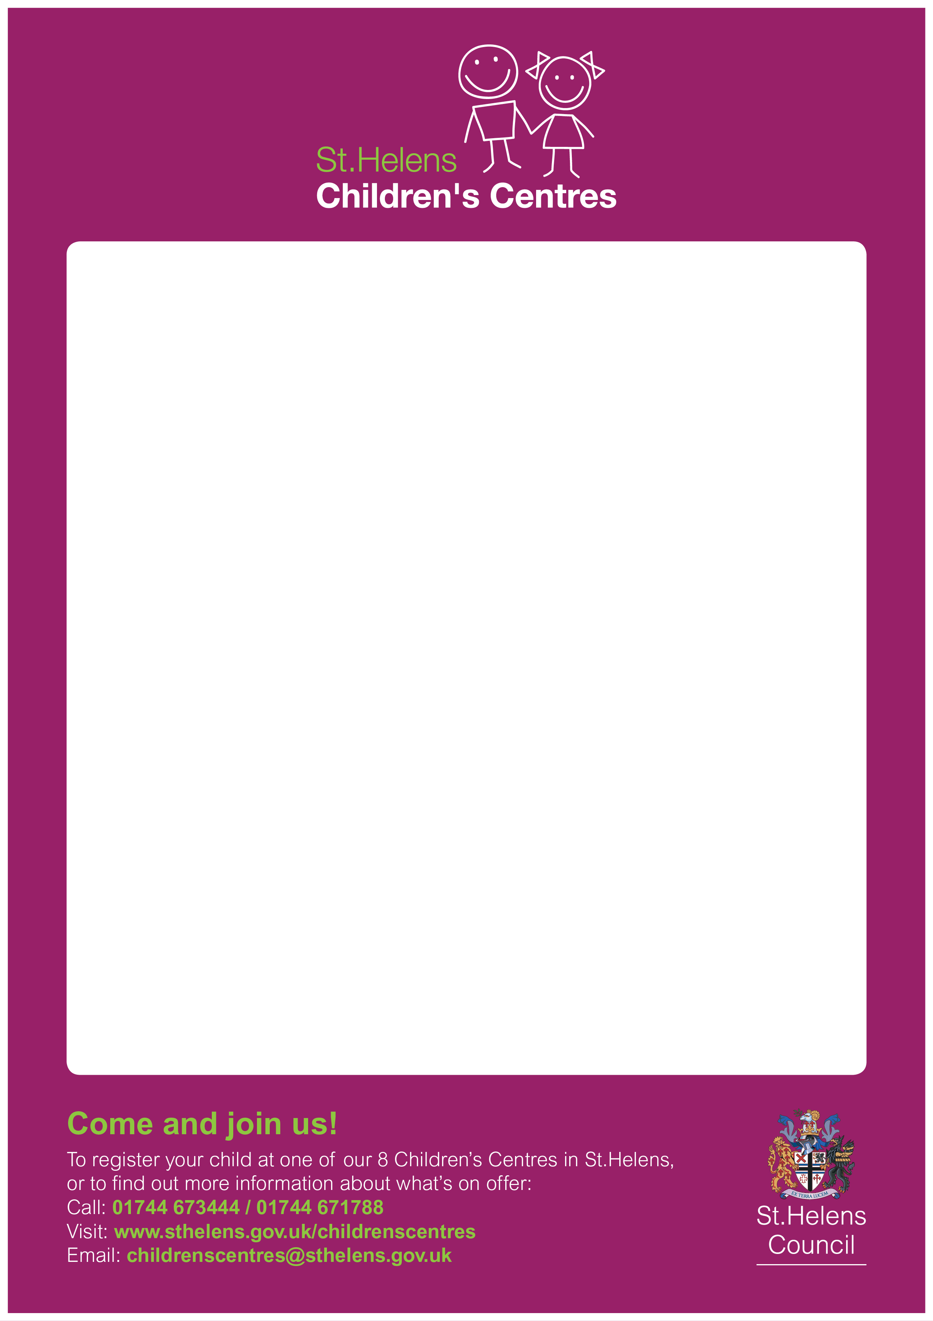
Two-Year-Old Funding Information

St Helens Children’s Centres will be holding information sessions at: -

Parr Children's Centre on
Wednesday 8th April 1.00 – 3.00pm

and

Central Link Children's Centre on
Tuesday 14th April 1.00pm - 3.00pm

This information session is aimed at Parent/Carers who have children who are approaching their 2nd birthday and are likely to be eligible for 2-year-old funding placement's.

Alison Naylor (Early Education Entitlement Manager) will be in attendance and will complete 2-year-old eligibility checks for any parents/carers who attend.
Andrea Molyneux (Department for Work and Pensions) will also attend to complete any benefit eligibility checks.

No need to book. Refreshments will be available.

