# **Learn to Love & Love to Learn…..in readiness for life**

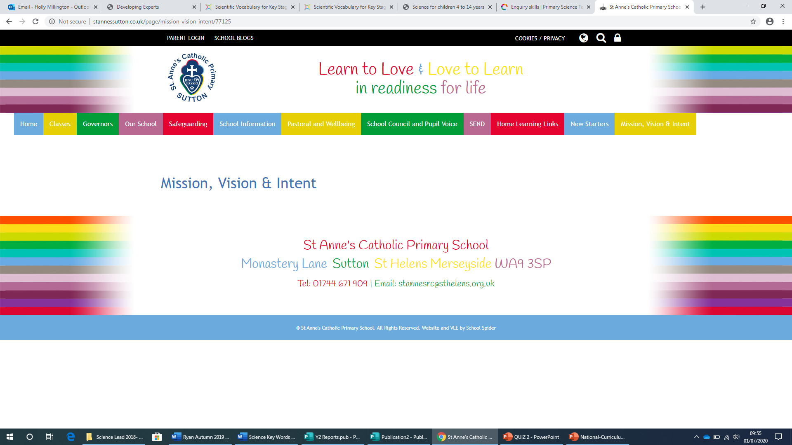

# 

# Friendship and

# Anti-Bullying Policy

# **2024-25**

**Statement of intent:**

At St Anne’s Catholic Primary School, we are committed to providing a caring, friendly and safe environment for all of our pupils so that everyone can learn effectively and fulfil their potential. Linked to the Gospel Values as our Catholic foundation, we promote ‘SCORE’ Values of: Self-Esteem, Commitment, Organisation, Resilience & Excellence as positive behaviours for learning and achievement. Our pupils and staff recognise and use these and their linked Gospel Values to create a culture of recognition of respect for the uniqueness of each individual in our school community

It is written into our school ***Mission Statement*** that St Anne’s is a school where “Everybody matters and everyone succeeds.”

This policy promotes Friendship, but relates to bullying of any kind, between children, or adults. **All types of bullying are unacceptable in our school** **and will not be tolerated.**

If bullying does occur, all children, their parents/carers and adults in the school should be able to **TELL** someone and know with confidence that incidents will be dealt with effectively.

**Objectives:** In keeping with our Catholic ethos and Mission Statement we believe that:

Our whole School community – Staff, Governors, Parents and Children should have an understanding of what friendship is and what bullying is. They should also know about our school policy on bullying and follow it should there be any incidents. As a school St Anne’s promotes friendship and takes bullying very seriously. We wholeheartedly support anyone who reports bullying.

***Quite simply Bullying will not be tolerated.***

**What is Friendship?**

In the words of our pupils, friendship is…

“Always accepting each other, no matter what”

“It doesn’t matter that we are all different, we are all special and that’s important”.

**What is bullying?**

Bullying is the repeated use of aggression with the intention of hurting another person. It is deliberate and ongoing. Bullying is usually pre-meditated and results in pain and distress to the victim. Bullying can happen outside school but has implications within school.

**Bullying can take the form of:**

· Emotional: humiliation, abuse, excluding, being unfriendly, tormenting, deceiving

· Psychological: hiding things, threatening gestures, coercion.

· Physical: Repeated pushing, kicking, hitting or other types of violence.

· Racist: Racial taunts,graffiti,gestures or focusing on the issue of race

· Sexual: Unwanted physical contact or sexually abusive comments

· Homophobic: Because of, or focussing on the issue of sexuality

· Verbal: name calling, sarcasm, spreading rumours, teasing.

· Cyber Bullying: The use of the internet, mobile phones or other technology to carry out many of the above.

**\*\*School shares with parents the expectation that** NO **children younger than the age of 13 (or associated age guidelines for all apps and sites) should be accessing them. \*\***

**See information below:**

**Reasons for bullying may include**

· being a victim themselves

· temporary trauma, emotional incident

· jealousy

· enjoyment of power

· low self esteem

· copying inappropriate behaviour e.g. television /Social Media

· attention seeking

· dislike of the victim

**Signs and symptoms of bullying**

· is frightened to walk to and from school

· reluctance to leave the house

· changes their usual routine

· becomes withdrawn, anxious or lacking in confidence

· starts stammering

· attempts or threatens suicide self-harm or runs away

· cries themselves to sleep at night or has nightmares

· feels ill in the morning

· school work begins to suffer

· asks for money or starts stealing money

· has unexplained cuts or bruises

· changes in behaviours

· loss of appetite

· is frightened to say what is wrong or denies anything is wrong

**The headteacher is responsible for:**

· Reviewing and amending this policy, accounting for new legislation and government guidance, and using staff experience of dealing with bullying incidents in previous years to improve procedures. · ·Ensuring the school keeps records of all reported incidents, including which type of bullying has occurred, to allow for proper analysis of the data collected.

· Analysing the data in the bullying record to identify trends, so that appropriate measures to tackle them can be implemented.

· Arranging appropriate training for staff members.

· Meeting with pupils and parents when bullying is identified and/or when more serious bullying incidents are evidenced to have occurred.

**Senior Leadership Team and Pupil Wellbeing Manager are responsible for:**

· Corresponding with and meeting with parents where necessary.

· Providing a point of contact for pupils and parents (Deputy Headteacher and Headteacher) when bullying is identified.

· Overseeing meetings with children and parents and support plans in initial stages.

· Restorative Justice sessions (Deputy Headteacher)

· Referrals to external support agencies for children and families

· Meeting with parents regularly throughout the process of any plans in place for children and/or families.

**Teachers are responsible for:**

· Being alert to social dynamics in their class.

· First point of contact for parents with concerns around friendship/bullying issues

· Being available for pupils who wish to report bullying.

· Providing follow-up support after any bullying incidents.

· Being alert to possible bullying situations, particularly exclusion from friendship groups, and informing teachers of such observations.

· Refraining from stereotyping when dealing with bullying.

· Understanding the composition of pupil groups, showing sensitivity to those who have been the victims of bullying.

· Reporting any instances of bullying once they have been approached by a pupil for support.

**To Parents/Carers:**

The first point of contact for any disputes your child may have with his/her peers is the class teacher. As soon as you have a concern, then raise this with the teacher so that the situation can be addressed directly and hopefully resolved swiftly. All children will be listened to objectively and given an opportunity to present their views.

**Parents are responsible for:**

· Informing their child’s teacher if they have any concerns that their child is the victim of bullying or involving in bullying in anyway.

· Being watchful of their child’s behaviour, attitude and characteristics and informing the relevant staff members of any changes.

· Ensuring that they observe the guidelines for age appropriateness regarding the use of social media and apps and not allowing their children to access apps and material outside of these guidelines – so as not to expose them to potential harm.

· Monitoring and checking their children’s devices for content and communications.

· Keeping evidence of cyberbullying and informing a member of staff with this evidence, should their child fall victim to cyberbullying.

· Reporting incidents of cyberbullying/online abuse to the Police and /or CEOPS should their child become a victim of online abuse.

· Capturing evidence of and sharing evidence with school to support in addressing any cyberbullying incidents happening outside of school found on their children’s devices, including any comments, conversations or other online material relating to all involved.

**Pupils are responsible for:**

· Informing a member of staff if they witness bullying or are a victim of bullying.

· Not making counter-threats if they are victims of bullying.

· Walking away from dangerous situations and avoiding involving other pupils in incidents.

· Keeping evidence of cyberbullying and informing a member of staff and their parents, should they fall victim to cyberbullying.

· Their own choices and behaviour in school.

If after all other communication and measures, you feel the situation has escalated and there has been no solution in the first instance, and you feel your child is being bullied, please do not approach the other parent or child involved. Contact the Headteacher immediately. The Headteacher will discuss the matter with you and from this discussion a plan will be put in place to monitor the situation and define a course of action in line with school policy and procedure.

If incidents have happened over the internet, or on social media it is useful to screen shot and print the evidence to share with staff so that this can be investigated and acted upon. Full conversations/messaging exchanges are required as much as possible.

**Procedures:**

**If bullying is established the following procedures will be implemented.**

Parents will be contacted and a meeting arranged.

1. All allegations will be recorded and investigated fully and recorded by staff on the schools CPOMS reporting system. Staff record and monitor all incidents in the log on CPOMS which details all anti-social, racist, homophobic incidents, child on child abuse and all bullying incidents if any are defined as meeting these criteria. This is reported by the Headteacher to Governors at termly Full Governing Body Meetings.

2. Children involved, including any witnesses will be interviewed - usually separately, or together if this is deemed necessary and appropriate.

3. Strategies will be used to support the children involved and help achieve a positive change in behaviour.

4. The school holds the expectation that parents will work in partnership with school, to enable the best outcomes for all.

**Examples of Strategies:**

· The child will be asked to reflect on his/her actions and will be supported in this to see the impact of their behaviour and the effect it is having on others/the other child.

· Possible use of the LA TESSA Behaviour Improvement Team – including Restorative Justice sessions led either by school or externally.

* A school based Pastoral Support Plan may be put in place, this involves the child, parents and school staff collaboratively, to encourage a positive change in behaviour and measure progress. This will be supervised and implemented by the Well-being and Welfare Managers and class teachers. It will be overseen by the Deputy Headteacher and /or the Assistant Headteachers, who will regularly update the Headteacher on the progress of the plan.
* A referral to the external School Counsellor may be put in place to support either the victim or support the perpetrator therapeutically with changing his/her behaviour and building resilience.
* Where a child involved is on the school SEND register, the SENDCO will also support and contribute to appropriate interventions to help address the situation. If necessary for SEND children involved, any related external professionals will be consulted in the plan for behaviour support
* Where it is felt that family support would be beneficial/necessary, school will recommend this, which may be, but not limited to: EHAT, Attendance Support Plan, (school based or through EWO) or referral to Level 2 support services within the Early Help Offer.
* Where a need for mental health support is identified beyond that of counselling support, school may refer to external services such as CAMHS and Barnardos.

4. If a further plan is put in place, a review date will be set to re-assess the situation.

5. Parents will be updated and invited to the review.

**Outcomes**: **Wherever possible all parties will be reconciled**. The situation will be monitored. If there is evidence over a period of time, that there has been no change in behaviour, the school will follow the graduated response to behaviour management as outlined in the School Attachment Aware Behaviour Policy.

**Parents/Carers:**

If after all communication and measures, there has been no resolution or improvement, please do not approach the other parent/s or child/ren involved. Contact the Headteacher immediately.

The Headteacher will discuss the matter with you and from this discussion a further plan will be put in place to monitor the situation and define an agreed course of action in line with school policy and procedure.

**If incidents have happened over the internet, or on social media it is useful to screen shot or video them/record voice notes and videos and print the evidence to share with staff so that this can be investigated and acted upon. Full conversations/messaging exchanges are required, as much as possible, to enable school to take fully informed, fair and reasonable action.**

**Prevention and teaching through a rich curriculum to create and embed a positive and strong culture of relationships and values.**

As a Catholic School, we follow the **To Know you More Clearly (and in Y4,5, and 6) Come and See Programmes** from Liverpool Archdiocese. This uses a themed approach which addresses relationships and other issues linked to bullying. We also use the **JIGSAW PSHE** scheme of teaching resources to ensure that themes and topics related to Friendship and Anti-Bullying are embedded within the curriculum and given high priority, alongside the **Journey in Love**, Relationship education programme from Liverpool Archdiocese. We employ various strategies and activities to help children recognise that all types of bullying are wrong, will not be tolerated and the different forms bullying may take. We aim to equip our children with the resilience and character reflective of the school’s Catholic ethos and Mission and to be proactive ambassadors themselves to prevent bullying in all forms.

**This is achieved by:**

* High expectations of all - across all aspects of school life, communicated effectively and consistently.
* Prompt, and informed action in the instance that any form of bullying should be identified.

· ‘Big Democracy’ – Democracy involving all our children on consultation for school policies and procedures in matters relating directly to them, including the Curriculum, inclusion, equality and diversity, the Behaviour Policy, rewards and sanctions and conflict resolution.

* Celebrating differences within our school community and beyond and educating our children on diversity, equality and inclusion through assembly, external visits and workshops and the curriculum across subjects – and reading.

· Class/Group discussions

* Pastoral Sessions and groups that work on friendship issues and resolutions

· The promotion of our SCORE Values and Gospel Values in everything we do

· Whole School and departmental assemblies

* Collective Worship, the Word of God shared as our Foundation, and which encompasses our behaviours and relationships as a Catholic school community.

· Theatre Groups and Visits from ‘The Power Of One’ /Altru Drama and other external agencies promoting Anti-Bullying at different times throughout the year

· Anti- Bullying Alliance Resources and celebration of Anti-Bullying Week, including the school’s Anti-bullying pledge reviewed annually

· Y6 House Captains and Vice Captains and Friendship Ambassadors in each year group are role models of our school expectations and values and offer support and encouragement to all children.

· Subject Ambassadors and Sports Ambassadors are ambassadors for behaviour for learning across the school, including role models of good relationships, conduct and team ethic.

· Reading Spine mapped out through the year groups and curriculum to reflect the school’s mission statement and also respect for diversity and equality within the school community and beyond.

· Wellbeing and Welfare Managers offering support in C@SA (Care @ St Anne’s) with the teaching of the Therapeutic School (TPC) mental health and wellbeing Curriculum.

* Targeted work in ESAFETY week.
* Jigsaw PSHE with RISE – resilience intervention to support children with their well-being and growth mindset.
* Support from The Listening Tree – External Counsellor working with identified children.
* Work with Mental Health Support Team for children.
* Support through membership for all staff and parents to My Family Coach – powered by Team Teach.
* Newsletters and invitations on workshops for parents, some to access with their children and some just for parents.

At St Anne’s we take great pride in our positive relationship with all parents and families. The school will communicate readily and act promptly to any identified concerns and issues. We will work with parents and carers in collaboration to ensure our school community is a happy and safe place for all our children.

This Policy should be read in association with the following school policies:

* Attachment Aware Behaviour Policy.
* SEND Policy
* Child Protection and Safeguarding Policy
* Child on Child Abuse Policy
* Online Safety Policy
* Acceptable us of ICT Policy/Agreements
* Mental Health and Well-being Policy

Policy to be reviewed: September 2025.