St Gerard’s Catholic Primary and Nursery School



St Anne’s Catholic Primary School

Intimate and Personal Care Policy
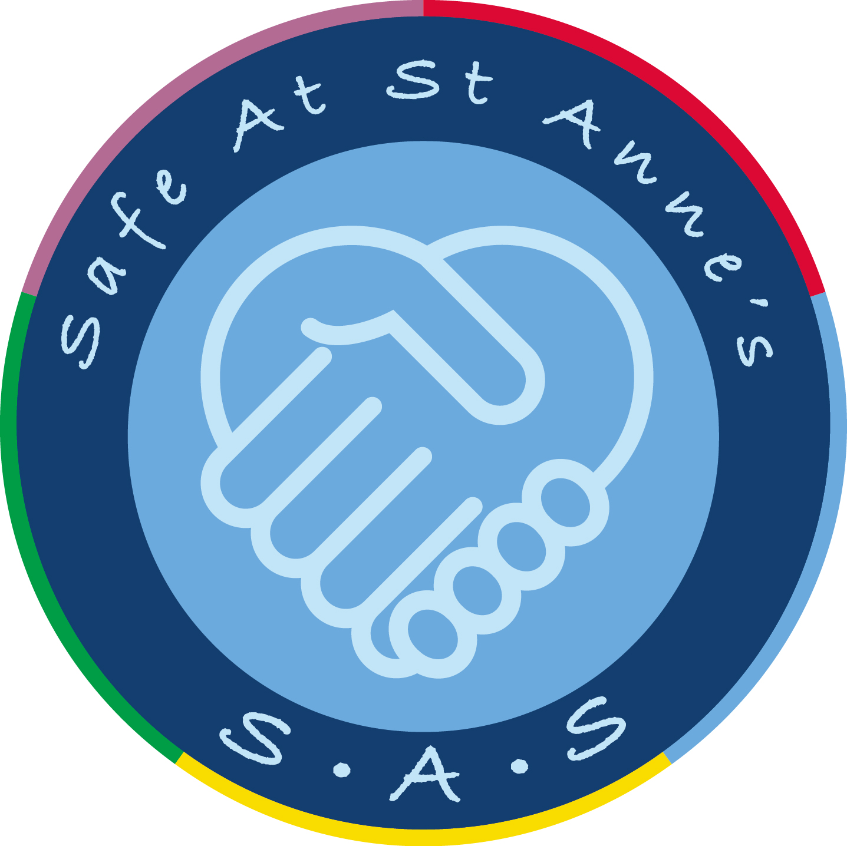

2023-24

Introduction

At St Anne’s Catholic Primary School we understand that children are at different developmental stages and, unless there are any medical or developmental reasons why this would not be appropriate, we work in partnership with parents to support them towards independent toilet training.

As a school we aim to be inclusive to all children and to give consideration to the individual needs of each child. We see toilet training as a self-care skill that all children should have the opportunity to learn through the full support and non-judgemental concern of adults.

This policy will be used when supporting children requiring nappy changing and other related personal care tasks. It has been written to ensure that best practice is always carried out and that procedures followed comply with the legal requirements of the Early Years Foundation Stage statutory framework.

Aims

- To ensure that children in our care are comfortable and happy at all times

- To safeguard the rights and promote the welfare of children
- To provide guidance and reassurance to staff who are required to change children

- To assure parents/carers that staff are knowledgeable about personal care and that their individual concerns are taken into account

- To protect children from discrimination and ensure the inclusion of all

Basic Principles

At St. Anne’s Catholic Primary School staff will bear in mind the following key principles when changing a child’s nappy:

- Children have the right to feel safe & secure
- Children will be respected and valued as individuals

- Children have a right to privacy / dignity

- In order to promote and develop greater independence, children need to be supported in their understanding of toileting procedures

- To ensure children are comfortable and happy, nappies will be checked at regular intervals and promptly changed when required. (I.e. when wet or soiled.)

Vulnerability to Abuse

As a school we ensure that all staff are familiar with our Safeguarding and Child Protection Policy as well as our procedures to help develop each child’s resilience and protect them from any form of abuse.

It is important that children are changed in a reassuring and caring way by a familiar staff member in the presence of another member of staff. Furthermore, it is important that we signal our intention to change a child’s nappy before doing so, ensuring that the child understands and anticipates what going to happen, as appropriate to their level of development. This helps give children the important message that not just anyone can pick them up, take them off and undress them.

Staff should always change children in the designated nappy changing area in the EYFS toilet area which, whilst allowing for privacy is not closed off. This is part of making sure there is a culture of openness which safeguards children and ensures all adults follow safe working practices.

Working with Parents/Carers

- We will work with parents when developing a child’s nappy changing routine.
- Where parents are present, e.g. during the settling in period, they will be asked to change their child’s nappy.

- If a child has any disability or medical need that may affect their personal care routine, an Education Health Care Plan (EHCP) will be drawn up in agreement with parents/carers.

- Parents will be asked when their child first starts at the nursery whether or not they have any particular needs or any special words or actions used during their nappy changing procedure.

- Any significant observations made during a nappy changing procedure will be notified to the parents at the end of the session (i.e. badly soiled nappy/strong urine etc.)
Achieving Continence

At St. Anne’s Catholic Primary School, we will encourage all children to achieve continence when they exhibit signs that they are ready. This will be achieved through modelling, positive praise, working with parents and having high expectations. In addition to this, EYFS staff will ensure that nappy changing times are relaxed and a time to promote increasing independence.

Protection for Staff

As far as possible, nappy changing procedures will be carried out by two members of staff. Protection for that person will be undertaken in the following ways:

  - Staff will be trained in good working practices which comply with Health and Safety regulations.

  - Staff will discreetly inform other members of staff that they are taking a child to the toilet to change. Each instance of intimate care will be recorded by the adult who completed it. Details recorded will include:

    - what personal care tasks were carried out
    - by who

    - the time and date it was completed

    - The PPE worn by staff members whilst conducting the change.

- Where staff are concerned about a child’s actions or comments whilst carrying out a personal care procedure, this should be recorded and discussed with the school’s designated safeguarding lead immediately.

- To ensure the safe moving and handling of children, parents’ will be asked to sign a consent form for their child to be lifted onto the nappy changing unit

Changing procedures followed by staff:

- Prepare the changing mat by cleaning it with antibacterial spray.

- Ensure the following items are ready before changing a child’s nappy; clean nappy, wipes and nappy cream if required. (N.B - where cream is used the child should have their own named cream and written permission obtained from the parent).

- Approach the child and say or communicate that it’s time for a nappy change.

- Wash and dry your hands and put on a pair of disposal gloves/disposable apron. (N.B - staff must put a fresh set of gloves on for every child that has a nappy changed.)

- Support the child on to the changing mat if required.
- Remove the child’s clothing to access the nappy.

- Staff members will then remove the child’s nappy and clean the area, always from front to back using wipes and cream provided by the parents/carers. The member of staff must ensure the child is clean and comfortable by putting on a clean nappy and a clean set of clothes if required.

- If the child’s clothes are soiled, they should be bagged separately and sent home, they should not be rinsed by hand.

- The staff member will then clean the changing mat with antibacterial spray.
- Soiled nappies will be placed into a tie handle bag then placed into the designated nappy bin.

- The staff member will then place the used gloves in the bin provided and wash their hands with liquid antibacterial soap and running water and then dry them on a disposable paper towel.

- Staff will help the child to wash their hands using liquid soap, warm water and paper towel and then take them back to the nursery room to continue with their activities/play.

- Staff will return to the nappy changing area, clean the changing mat, surrounding area and underneath the mat before leaving to dry.

Toilet Trained/Training

- If a child is old enough to meet his own toileting needs, the staff member can support the child according to age and ability to use the toilet, ensure they are comfortable, clean and dry and have washed their hands afterwards.

- When supporting a child that needs to be changed the staff member will approach the child and explain that they would need to clean and change them into some dry clothes.

- The staff member will put on a pair of disposable gloves/apron.
- Remove the wet/soiled clothes from the child.
- Clean the areas that need cleaning/ a shower might need to be used in some circumstances. The staff member will talk through with the child what they are about to do so that they are happy and understand. If a child is capable of doing so they can help with the removal of any clothing.

- Wet/soiled clothing will be put into a bag so that they can be sent home.

- Staff member will wash their hands with antibacterial soap and running water and then dry them on a disposable paper towel.

- Staff will help the child to wash their hands using liquid soap, warm water and paper towel and then take them back to the nursery /classroom to continue with their activities/play.

- Staff will return to the changing area and clean it if required. The area will then either be closed until dry or a wet sign would be placed up.

Parental Responsibilities

At St. Anne’s Catholic Primary School we work in partnership with parents and ask them to assist us by ensuring the following:

- Parents understand and agree the procedures that will be followed when their child is changed at school.
- Parents must sign a consent form granting permission for their child’s nappy to be changed.

- The school requires parents to supply nappies, wipes and sundries that will be used and applied as necessary.

- Parents understand that they will be asked to collect their child from school if their child shows symptoms of illness or indications of ill health.

- Parents must send their child in nappies or protective underwear until they are dry and clean the majority of the time.

Sanitary Wear

As a school we provide sanitary wear if required. The girl’s toilets and adult toilet are all provided with sanitary bins for hygiene purposes.

Policy Review Date: July 2024

