**SEN Flow Chart**A potential SEND is identified by parent, teacher or outside agency.



**Monitoring:**A concern is raised by the child’s parent or class teacher.  
The class teacher is responsible for informing the SENDCO (Mrs.Porter)  
The class teacher completes a Cause for Concern Sheet for the child outlining:  
*what support has been in place  
*what support has been planned (put on IEP / IBP)  
The class teacher also liases with the child’s parent.

**Monitoring:**A concern is raised by outside agency.  
If appropriate, the SENDC0 (Mrs.Porter) chairs a meeting involving all stakeholders (including parents and class teacher) to discuss concern. The class teacher completes a Concerns Sheet for the child outlining:  
*what support has been in place  
*what support has been planned



**Ongoing Monitoring: As part of the Graduated Response of Assess, Plan, Review and Do**

Ongoing monitoring (by class teacher) of the provision outlined on the Cause for Concern Sheet. The child’s progress is monitored closely by class teacher for 6 weeks and observations are completed. The date for the review is noted on Cause for Concerns Sheet and IEP. The class teacher will discuss progress with SENDCO after 6 weeks.





The child’s needs are met. Progress is referenced on the Cause for Concern Sheet. The child may continue to need intervention to support their progress. The class teacher is responsible for passing information onto SENDCO and continue monitoring progress.









**No further concern**  
If child is on track and there is no further concern they are removed from register after a period of time and the attainment is reviewed through existing pupil progress reviews within school involving class teacher and SLT.

**Review identifies external advice needed**Parents informed of further concerns and agree to the referral. Support is requested from outside agencies for advice and assessment. Parents are informed of outcome.  
Continue to assess progress and collect evidence.

**EHCP**If concern continues and additional and different support exceeds the funding delegated to the school budget for SEN an application for an EHCP assessment or full EHCP will be completed. Parents will be involved in the process.

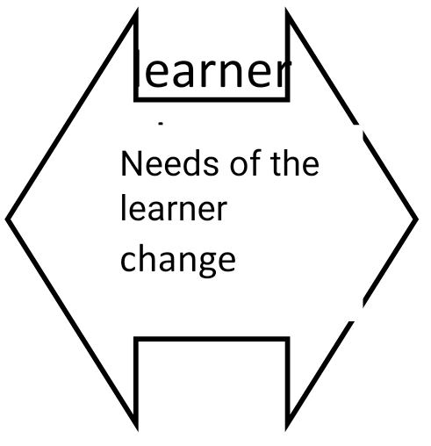

learner change

Needs of the learner change