Art and Design Curriculum – Cycle A
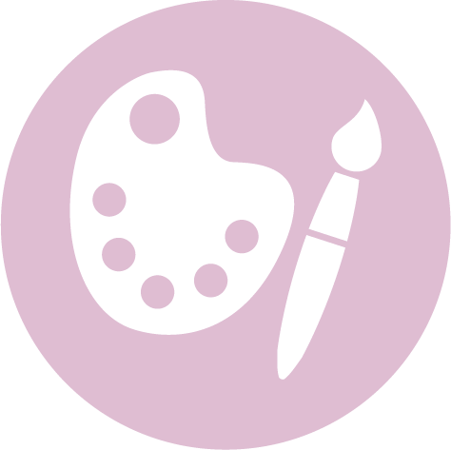

Lower Key Stage 2 – Year 3 & 4
- to create sketch books to record their observations and use them to review and revisit ideas
- to improve their mastery of art and design techniques, including drawing, painting and sculpture with a range of materials [for example, pencil, charcoal, paint, clay]
- about great artists, architects and designers in history.

Autumn | Spring | Summer
Unit Title:Drawing and Colour – Abstract Art |  | Unit Title: Printing – Fabric
Artist:Joseph Amedokpo 1946 –  Movement: Post Modernism  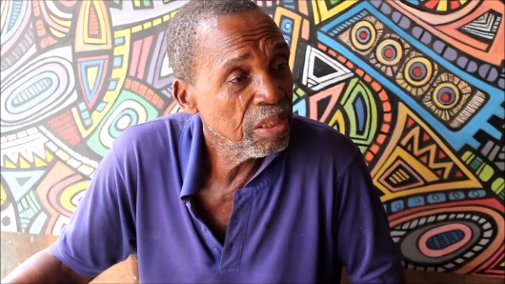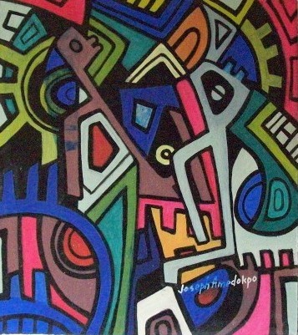  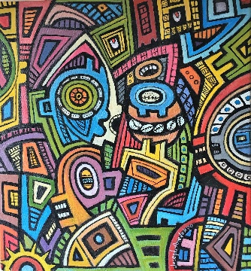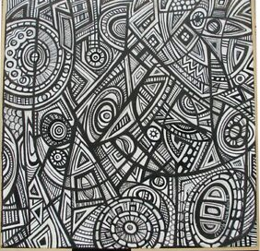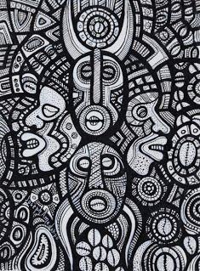  https://www.bbc.co.uk/teach/abstract-art-timeline-colour-and-shape/zmhy6v4  https://en.wikipedia.org/wiki/Joseph_Amedokpo  https://www.youtube.com/watch?v=8YasMdBTJ3A |  | Artist:HapaZome (technique)  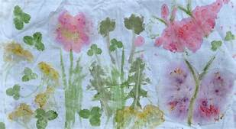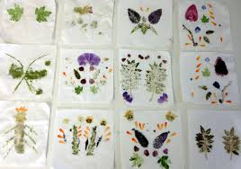  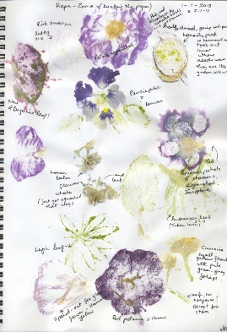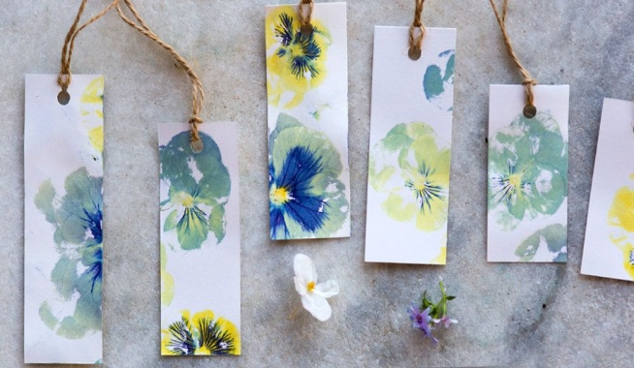  https://muddyfaces.co.uk/activity/hapa-zome-leaf-bashing-prints/  https://www.youtube.com/watch?v=GYooM517_gI  https://www.bbc.co.uk/teach/class-clips-video/art-and-design-printmaking-different-materials/zhytscw
Prior Knowledge: KS1  Pupils should be taught:  - to use a range of materials creatively to design and make products  - to use drawing, painting and sculpture to develop and share their ideas, experiences and imagination  - to develop a wide range of art and design techniques in using colour, pattern, texture, line, shape, form and space  - about the work of a range of artists, craft makers and designers, describing the differences and similarities between different practices and disciplines, and making links to their own work  Prior Vocabulary:  Materials  Drawing, painting  Colour, pattern, texture, line, shape, form space  Artists, craft makers, designers  Similar, different |  | Prior Knowledge: KS1  Pupils should be taught:  - to use a range of materials creatively to design and make products  - to use drawing, painting and sculpture to develop and share their ideas, experiences and imagination  - to develop a wide range of art and design techniques in using colour, pattern, texture, line, shape, form and space  - about the work of a range of artists, craft makers and designers, describing the differences and similarities between different practices and disciplines, and making links to their own work  Prior Vocabulary:  Materials  Drawing, painting  Colour, pattern, texture, line, shape, form space  Artists, craft makers, designers  Similar, different
Skills:  - Understand and identify key aspects such as complementary colours, colour as tone, warm and cold colours. (3)  - Create different effects by using a variety of tools and techniques such as bleeds, washes, scratches and splashes. (4) |  | Skills:  - Create printing blocks using relief or impressed techniques. (3)  - Understand and identify key aspects such as complementary colours, colour as tone, warm and cold colours. (3)  - Use a variety of printing techniques. (4)  - Compare and recreate form of natural and manmade objects. (3)  - Print on fabrics (4)
Knowledge:  - Use a sketchbook for recording observations, for experimenting withtechniques or planning out ideas. (3)  - Experiment with different materials to create a range of effects and usethese techniques in the completed piece of work. (3)  - Explain what he/she likes or dislikes about their work. (3)  - Know about some of the great artists, architects and designers in historyand describe their work. (3)  - Use a sketchbook for collecting ideas and developing a plan for a  completed piece of artwork. (4)  - Use taught technical skills to adapt and improve his/her work. (4)  - Articulate how he/she might improve their work using technical terms andreasons as a matter of routine. (4)  - Describe some of the key ideas, techniques and working practices of artists,architects and designers who he/she has studied. (4) |  | Knowledge:  - Use a sketchbook for recording observations, for experimenting withtechniques or planning out ideas. (3)  - Experiment with different materials to create a range of effects and usethese techniques in the completed piece of work. (3)  - Explain what he/she likes or dislikes about their work. (3)  - Know about some of the great artists, architects and designers in historyand describe their work. (3)  - Use a sketchbook for collecting ideas and developing a plan for a  completed piece of artwork. (4)  - Use taught technical skills to adapt and improve his/her work. (4)  - Articulate how he/she might improve their work using technical terms andreasons as a matter of routine. (4)  - Describe some of the key ideas, techniques and working practices of artists,architects and designers who he/she has studied. (4)
Key moments in sketchbook:  - Artist research –Joseph Amedokpo  - Experiment with different techniques to show complementary colours, colour as tone, warm and cold colours.  - Experiment with different effects, tools and techniques.  - Annotations to show reflections on their work and that of others. |  | Key moments in sketchbook:  - Experiment with a range of printing techniques.  - Experiment with a range of natural materials.  - Experiment with colour, form, texture.  - Photos of temporary art works.  - Annotations to show reflections on their work and that of others.
Final artwork:  An Amedokpo inspired piece of abstract art |  | Final artwork:  A print design using the Hapazome technique
Key Vocabulary:  Elements of art - Colour, line, shape, space  Vibrant, bold  Warm/cold colours  Abstract/abstraction  Legacy  Modernism |  | Key Vocabulary:  Elements of art – colour, shape, texture,  Impression, print  Natural/man made  Parts of plants/flowers  Hapazome - hammering, pattern, shape, effect, colour, dye  Bruise  Natural colours
Curriculum links:  History |  | Curriculum links:  Geography – human and physical geography  Science – plants and living things
Jobs in Art & Design:  Fashion, textile designers  Architect  Interior designer  Animator  Illustrator  Web designer  Graphic designer  Photographer  Computer aided designer |  | Jobs in Art & Design:  Fashion, textile designers  Architect  Interior designer  Animator  Illustrator  Web designer  Graphic designer  Photographer  Computer aided designer

