St Anne’s Catholic Primary School – Geography Long Term Plan

EYFS | Running throughout the year: Understanding the world – People, culture and communities and The Natural World.  People, culture and communities  -Describe their immediate environment using knowledge from observation, discussion, stories, non-fiction texts and maps;  - Know some similarities and differences between different religious and cultural  communities in this country, drawing on their experiences and what has been read in class;  - Explain some similarities and differences between life in this country and life in other countries, drawing on knowledge from stories, non-fiction texts and – when appropriate – maps.  The natural world  -Explore the natural world around them, making observations and drawing pictures of animals and plants;  -Know some similarities and differences between the natural world around them and contrasting environments, drawing on their experiences and what has been read in class;  -Understand some important processes and changes in the natural world around them, including the seasons and changing states of matter.
 | 1 week | 1 week | 1 week | 1 week
Key stage 1 | The school | The United Kingdom + Capital Cities | Continents and Climate  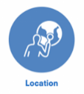 | St Helens and Nairobi including weather
Lower Key Stage 2 | Mountains  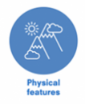 | 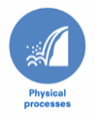  Earthquakes and volcanoes: plate tectonics | The Community of Madrid, The North West of England and South America  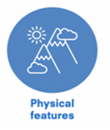 | International Transportation
Upper Key Stage 2 | Landscapes of the UK  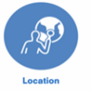 | Europe inc Russia | Describing maps of the world | Biomes and Climate zones  